Task No & Title: Unit 2 | Unit Descriptor Unit Descriptor This unit describes the performance outcomes, skills and knowledge required to participate in workplace occupational health and safety (OHS) processes to protect workers own health and safety, and that of others.No licensing, legislative, regulatory or certification requirements apply to this unit at the time of endorsement.
Title: | Follow workplace safety procedures
Suitable for Classes: | Certificate II in Information Technology
Area: | Technology & Enterprise
Teacher: | Mr Peter Faulks
Timeline | 1 Lesson
Date Due: | Today

Task Brief:

Files Required

Items highlighted in yellow are tasks for you to complete
Items in Purple are help tips
Certificate II in Information Technology
BSBCMN106A Follow workplace safety procedures
1 | ICAU1128B Operate personal computer | Pre | 20 hours
2 | BSBCMN106A Follow workplace safety procedures | Core | 10
3 | ICAD2012B Design organisational documents using computing packages | Core | 40
4 | CAU2005B Operate computer hardware | Core | 20
5 | ICAU2006B Operate computing packages | Core | 60
6 | ICAU2013A Integrate Commercial computing packages | Core | 25
7 | ICAU2231B Use computer operating system | Core | 20
8 | ICAW2001B Work effectively in an IT environment | Core | 25
9 | ICAW2002B Communicate in the workplace | Elective | 20
10 | ICAS2014B Connect Hardware Peripherals | Elective | 25
11 | ICAU2007B Maintenance of equipment and consumables | Elective | 15
12 | ICPMM263B Access and use the internet | Elective | 20
13 | ICAW2011B Work individually or as a team member | Elective | 20
14 | ICPMM321B Capture a digital image | Elective | 30

Save the work

Anthropometrics and ergonomics
Anthropometrics is the comparative study of human body measurements and properties. Ergonomics is the science of making the work environment safer and more comfortable for workers using design and anthropometric data.

Ergonomics
The prolonged use of computing equipment, especially the keyboard and mouse can cause serious physical injuries. Some of the injuries include damage to vision repetitive strain or stress and overuse syndrome. These injuries can be minimised by the taking of simple precautions and in particular taking care of our posture.
With more and more occupations requiring the use of information technology equipment in the daily operations, ergonomics and the design of equipment and furniture is increasing in importance. Hence, the office (and even the home) environment is a specialised area that needs to be looked at separately in terms of the design of office furniture and equipment.

Experiment
If you have access to the Internet, trying using a search engine such as Google or AltaVista to find ergonomically designed furniture and equipment.

Anthropometrics  Ergonomics has been influenced by anthropometrics. Research of the human body has established that there is no average human. Everybody is different and office furniture and equipment needs to be designed with this in mind. For example chairs and desks need to be able to cater for all sizes therefore seats must be adjustable by height and tilt depending on the tasks being carried out. | 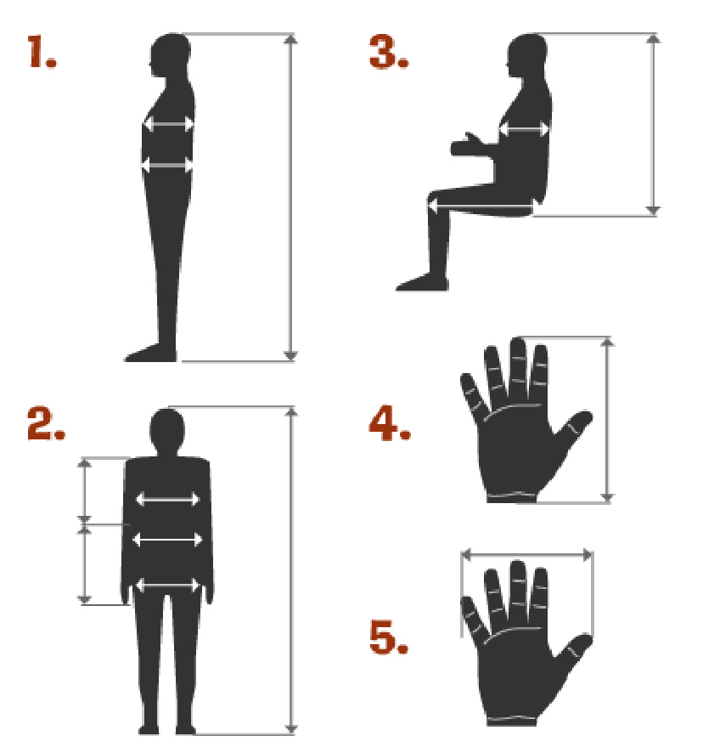

Experiment
Use the diagrams as a guide to measure all of your family members.

Compare their measurements.

Record your results in the table and answer the following questions:
 | Hand | Arm | Leg | Foot
You
Mum
Dad
Brother
Sister

1. How do you adjust the height of your equipment to meet differences in height of your family members?

2. How might the hand span measurements impact on the choice of mouse used with the computer?

Save your work as (your initials)_anthropometrics into your AIT Portfolio.

Evaluation Individual Task

Task Number

Your Name Date

Consider the Task that you have recently completed, carefully and critically evaluate your work by answering the following questions.

1. What was the purpose of the task part a?
Answer:
What was the purpose of the task part b?
Answer:

2. Who was your intended audience of your tasks?
Answer:

3. How well do you think your design suits the intended audience?
□  Very well | □  Quite well | □  Not sure | □  Could be improved | □  Audience not considered in the design

4. Have you been able to test your design on someone from your intended audience group?
What was their reaction?
Answer:

5. How many samples were you able to view to help you investigate your topic for the power point?
□  None | □  1 or 2 | □  About 5 | □  Between  5 and 10 | □  More than 10

6. How did you decide which software to use for your background?
□  I produced several versions in different software and chose the best | □  I did some drafts in a couple of applications and chose the best one to complete it in | □  I began using one application and swapped to another when my skill levels increased | □  I only used one of the suggested applications | □  I only tried word processing software

7. How original was your design?
□  I copied a design I had seen elsewhere | □  I copied a design and changed the colouring and shapes | □  I used a variety of designs and combined different aspects of them | □  I used a variety of ideas as inspiration and then developed my design | □  Completely original

8. Did you produce and keep draft copies of your background and your written response?
□  Yes, my pencil and paper drafts are in my hardcopy portfolio and my digital copies are in my electronic portfolio | □  Yes but only a digital draft version | □  Yes but I only kept a hardcopy draft | □  Yes I did but I didn’t keep any copies | □  No, only a final copy

9. Are you happy with your image manipulation skills at this stage?
□ Yes □ No
Explain
Answer:

10. Would you like to develop your skills in image manipulation further since completing this task?
□ Yes □ No

11. Did you find any restrictions to your ability to manipulate your images?
Answer:

12. Did you check your task for spelling and grammar mistakes?
□ Yes □ No

Why / Why not?
Answer:

13. How did you feel about your time management for Task 1?
□  I need a lot more time to finish my event item properly | □  I spent more time than suggested in preparing my event item | □  It took me about the same time suggested in the course to complete my event item | □  I was able to work quite quickly and had some time to spare | □  I worked very quickly and was able to spend time refining my item through learning more application tools
14. Have another look at the Scenario and the Task 1 Explained. Do you believe this item meets the requirements of the task? Explain
Answer:

Save your evaluations as (your initials)_task_eval into your folder, attach it to the web link site or email it to me before the end of the week.


Student Name: | Date submitted:
I declare this evidence to have been produced by me the undersigned.

Candidate’s signature:
Title of Portfolio evidence presented (include Unit No and section i.e. 03.05)
:-
□ Outcomes from learning programs (including self-learning and online learning)
□ Assessment feedback (from a trainer or assessor)
□ Observation checklists (from a workplace supervisor or assessor)
□ Written statements or references (including workplace supervisors, community leaders)
□ Job descriptions
□ Work journal
□ Work samples
□ Finished products
□ Product descriptions or specifications (supporting the product samples included)
□ Statutory declarations
□ List others (or delete any from above not provided)
- All work submitted to be word processed and spell checked.
- There must be at least two samples of evidence for each
Element within the Unit of Competency. This is sample 1 / 2
- All work submitted must be of a high quality and meet the
requirements of the Unit of Competency.
Other evidence (List each piece):
Assessor to complete
Evidence is Valid Sufficient Authentic Current
□ □ □ □

Assessor signature: _________________________________Date: _____________
Peter Faulks, BA Soc Sci, Grad Dip Ed, Cert IV AWT
Certificate II in Information Technology assessor/teacher
Assessor to complete

Student is declared Competent Not Yet Competent
□ □

Keep a copy of this report with your file for evidence

